14.1.6 Editors - Movie Clip Editor - Header - Tracking Mode - Clip Submode - Track Menu
Track Menu 2
Clear Solution 2
Clear Track Path 2
Lock 2
Unlock 2
Copy 2
Paste 2
Copy Track Settings 2
Copy Color 2
Insert Keyframe 2
Delete Keyframe 2
Join Tracks 3
Show/Hide 3
Show Hidden 3
Hide Selected 3
Hide Unselected 3
Last operator Hide Tracks 3
Unselected 3
Transform 3
Move 3
Last Operator Move Last 3
Move X Y Z 3
Axis Ortho 3
Orientation 3
Proportional editing 4
Proportional Falloff 4
Proportional Size 4
Connected 4
Projected(2D) 4
Resize 4
Last Operator Resize Last 4
Resize X Y Z 4
Orientation 4
Proportional editing 4
Proportional Falloff 4
Proportional Size 4
Connected 5
Projected(2D) 5
Reconstruction 5

Track Menu

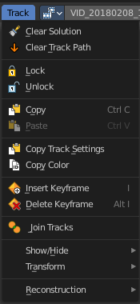
Clear Solution
Clears all calculated data.

Clear Track Path
Clears the currently active Track Path.

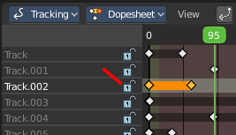
Lock
Locks the track in the dope sheet sub mode panel.

Unlock
Unlocks the track in the dope sheet sub mode panel.

Copy
Copy selected tracks to clipboard.

Paste
Pastes selected tracks from clipboard.

Copy Track Settings
Copies track settings from active to selected track. You need to select the source track first, then hold down shift, then select the target track. Then perform copy track settings.

Copy Color
Copies color to all selected tracks. What color? Ask the Blender developers ...

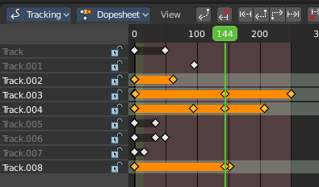
Insert Keyframe
Inserts a keyframe at current position in spreadsheet sub mode panel.

Delete Keyframe
Deletes keyframes at current position in dope sheet sub mode panel.

Join Tracks
Joins the selected tracks.

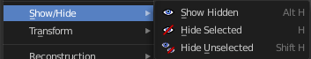
Show/Hide
Show or hide tracks.

Show Hidden
Show all hidden tracks.

Hide Selected
Hide the selected tracks.

Hide Unselected
Hide the unselected tracks.

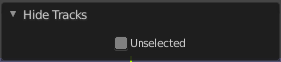
Last operator Hide Tracks

Unselected
Hide selected or unselected tracks.

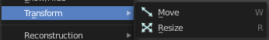
Transform
Track navigation.

Move
Move the selected track(s).

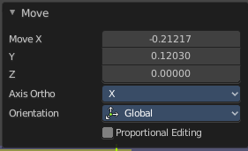
Last Operator Move Last

Move X Y Z
The transform values. Set x and y position of the track. Z value has no influence.

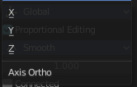
Axis Ortho
Defines the other axis of an imaginary shear axis plane.

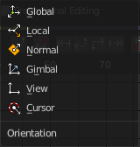
Orientation
Choose the orientation for the shear action.

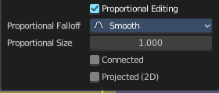
Proportional editing
Enables proportional editing. Activating proportional editing reveals further settings.

Proportional Falloff
Adjust the falloff methods.

Proportional Size
See and adjust the falloff radius.

Connected
The proportional falloff gets calculated for connected parts only.

Projected(2D)
The proportional falloff gets calculated in the screen space. Depth doesn't play a role. When it's in the radius, then it gets calculated.

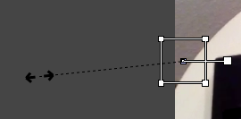
Resize
Resize the selected track(s).

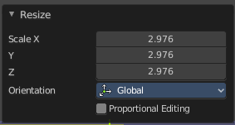
Last Operator Resize Last

Resize X Y Z
The transform values. Set x and y position of the track. Z value has no influence.

Orientation
Choose the orientation for the shear action.

Proportional editing
Enables proportional editing. Activating proportional editing reveals further settings.

Proportional Falloff
Adjust the falloff methods.

Proportional Size
See and adjust the falloff radius.

Connected
The proportional falloff gets calculated for connected parts only.

Projected(2D)
The proportional falloff gets calculated in the screen space. Depth doesn't play a role. When it's in the radius, then it gets calculated.

Reconstruction
This menu once contained nothing but double menu entries that can be found in the panels. It is part of the Blender menu structure. And a add-on may add an entry here. So it remains for compatibility reasons.

